Lecture 16: Nerve System

10801040 莊博恩、10801128 陳俊鴻

1. Brief Intro
2. Neurotransmitters：有兩種方式釋出，一種是merge＆recycle(透過endocytosis重新製造vesicle)另一種是kiss＆run(vesicle釋放完Neurotransmitters後直接被回收)；某些疾病中neurotransmitters不夠，可以block neurotransmitters transporter來舒緩，在postsynapse上的receptor(ion gated channel)接收neurotransmitters後會打開，產生的膜電位改變分為EPSP(促進action potential)與IPSP(抑制action potential)
3. Habitualization＆sensitization：habitualization為生物體面對同樣重複性的刺激時，反應的強度會逐漸降低(不再需要那麼費力去面對每一個刺激)，在neurotransmitters的分泌會減少；sensitization為使presynapse在接受刺激後快速釋放neurotransmitters，加大生物體對刺激的response，例如：海蝸牛來自tail的神經透過serotonin間接引起蛋白質的磷酸化反應，使presynapse terminal在接受siphon的訊號後能快速的反應。
4. 短期記憶轉換成長期記憶：透過改變結構(需要新的蛋白的合成)，方法為生物體一直接受刺激導致PKA persistent activation，PKA跑到細胞核後磷酸化transcription factor，使一個gene的promoter被打開，進而改變synapse的結構(例如：讓數目變多)
5. Hebb’s hyposis：神經A的axon很接近B，且可以持續刺激B，可能就會有growth process發生，使A和B wire在一起，此為記憶的基礎。
6. Synapse strength：連結兩個synapse的強度是可以被改變的，例如LTP：若在短時間內皆收到一個很強烈的訊號，對接下來的訊號有一長段時間神經細胞response都會較baseline大，分子機制可以用AMPA和NMPA receptor解釋(當原本會和glutamate結合但不會打開的NMPA receptor接收到一個depolarization時會被打開，AMPA和NMPA receptor同時打開使Ca+大量進入，turn on酵素和gene expression，改變postsynapse的結構，使往後接收到刺激時反應都會不同)
7. Q&A

Question 1:

老師上課有提到痛覺的傳導是依賴刺激small fibers並傳到中樞，在大腦形成痛覺，此時我想到了臨床上常見的應用—在手術執行麻醉時，是利用何種分子機制使病人暫時感受不到痛覺？

Answer 1:

我認為很可能和切斷訊息傳導有關(使痛覺的訊息最終無法傳到中樞)

想到的可能機制如下：

1. 麻醉劑使神經元暫時失去傳導的功能，例如軸突上的離子通道蛋白被麻醉劑作用而強制封閉，無法形成action potential
2. 神經元沒有問題，但是訊息傳到突觸化為neurotransmitter時，麻醉劑作為Competitive inhibitor和neurotransmitter結合，使訊息無法繼續傳遞。

經查詢發現麻醉分為局部麻醉(Local anesthesia)與全身麻醉(general anesthesia)

執行local anesthesia最主要的藥物為lidocaine，作用方式為anesthetics會先進入神經細胞內，並在細胞內和voltage-gated sodium channels結合，並阻擋sodium channels開啟，sodium channels是使訊號沿神經細胞傳遞的重要通道，當足夠數量的通道被block，神經纖維內的impulse transmission就會被阻擋，因此較小的纖維(sodium channels數量較少)較容易受到Local anesthesia影響。

另外，在神經元為activated和inactivated states時，Local anesthetics和sodium channels的親和力較好，故有較快firing rates的神經元也比較容易受到Local anesthesia影響。

Yeh showed that the anesthetics produced a blockade of the sodium channel that was dependent on both the membrane potential and the frequency of any action potentials currently passing through the axon using the sodium channels, thus explaining how local anesthetics may perturb transmission of the action potential through nerve ﬁbers.

Starmer et al. subsequently tested whether local anesthetic mediated sodium channel blockade was the result of local anesthetic compounds being trapped within a cell and then binding receptors from within (Starmer et al., 1986). In the giant squid axon, they observed that local anesthetics bound to the interior of the ion channel.

Local anesthetics have greater affinity for receptors within sodium channels during their activated and inactivated states than when they are in their resting states.[1](https://www.ncbi.nlm.nih.gov/pmc/articles/PMC3403589/#i0003-3006-59-2-90-Berde1),[2](https://www.ncbi.nlm.nih.gov/pmc/articles/PMC3403589/#i0003-3006-59-2-90-Katzung1) Therefore, neural fibers having more rapid firing rates are most susceptible to local anesthetic action. Also, smaller fibers are generally more susceptible, because a given volume of local anesthetic solution can more readily block the requisite number of sodium channels for impulse transmission to be entirely interrupted. [1]

那全身麻醉是如何執行的？首先我想到的是作用區域可很能是中樞神經系統，因為若假設麻醉劑須隨著血流流到全身，像局部麻醉一樣阻斷身體某部位的神經傳遞，非常沒有效率，且麻醉劑的量會需要很大(因為要擴散到全身的神經細胞)，對人體是一大傷害，相較之下，若麻醉劑只作用在最後產生痛覺的中樞神經部分，在大腦或脊髓內阻斷中樞的神經訊號(或是將要傳遞到中樞的訊號)，不僅比較容易控制、可以確保痛覺消失，也能避免人體接受過量麻醉劑，似乎比較合理。

經查詢後得知，全身麻醉的機制主要的確作用在中樞神經，且除了讓人體暫時失去痛覺，全身麻醉還有其他作用：

The association between the functions of general anesthetics and specific sites of CNS has been recently discovered. The immobility function of inhalation anesthetics by noxious stimuli primarily acts on the spinal cord, not being connected with the brain [6].

Although there is insufficient evidence to prove the association between specific sites of the brain and the functional sites of general anesthetics, there are some cases that are gradually revealed. The amnesia effect of general anesthetics is closely related with the hippocampus [7,8]. Sedation is related to the neocortex [9] and thalamus [10], and hypothalamus is presumably the hypnotic action part. [2]

使全身失去動作能力作用於骨髓，失去記憶(amnesia effect)作用於hippocampus、鎮靜(Sedation)和neocortex及thalamus有關、催眠(hypnotic action)則和hypothalamus有關，當位於這些區域的神經傳遞中斷，就很可能在生理上造成不同影響，像amnesia effect、sedation…等。

而就細部的機制來講，全身麻醉(general anesthesia)主要作用則是在postsynaptic receptor(ligand gated ion channel)，加強neurotransmitters的作用，最主要的作用為anesthesia可以加強GABAA receptor和GABA結合後所產生的IPSCs(GABAA receptor為氯離子通道，氯離子進入後會減緩action potential的發生)，anesthesia可以同時減緩GABAA receptors的desensitization，延長IPSCs的持續時間(更多氯離子進入)，使action potential更不容易發生。甚至在GABA不存在時，較高濃度的anesthesia也可以直接活化GABAA receptor

Excitatory neurotransmitters, for example glutamate and acetylcholine, cause depolarization. Conversely, inhibitory neurotransmitters, such as α-aminobutyric acid (GABA) and glycine, reduce postsynaptic activity. The free neurotransmitters bind with ion channel receptors to control the flow of ions. The control of cell electrical activity by ion channels is closely linked with the physiologic action of anesthetics and the various behavioral response patterns to them (Table 1) [11]. Among ion channels, GABAA, glycine, nicotinic acetylcholine, and N-methyl-D-aspartate (NMDA) receptors show sensitivity to general anesthetics [1-4]. Some of the volatile anesthetics also act on potassium channels and voltage-gated channels (sodium, calcium) [12-14]. Typically, general anesthetics potentiate the activation of inhibitory postsynaptic channels or inhibit the activation of excitatory synaptic channels

General anesthetics enhance the action of the neurotransmitter GABA on the GABAA receptor. They potentiate IPSCs generated by the synaptic GABAA receptor [1,2,28]. In addition, several anesthetics have been shown to reduce desensitization of GABAA receptors [28,29] (Fig. 2A and B). At higher concentration, anesthetics directly activate GABAA receptors without the help of GABA [28].

除了GABAA receptor之外，還有其他receptor也是general anesthetics的作用目標：

被活化的receptor：

1. Glycine receptors(氯離子通道蛋白，產生IPSCs)
2. Potassium channels(此為two-pore-domain potassium channels)，使鉀離子流入細胞，造成hyperpolarization

被抑制的receptor：

1. Nicotinic acetylcholine receptors(鈣離子等陽離子通道蛋白，產生EPSCs)
2. Glutamate receptors(鈣、鈉、鎂離子通道蛋白，產生EPSCs)
3. Sodium channels(此指位於presynaptic的voltage-gated sodium channels)，抑制action potential讓neurotransmitters無法釋放

也就是說，general anesthesia 會加強inhibitory postsynaptic channels的活化，並抑制excitatory synaptic channels活化。

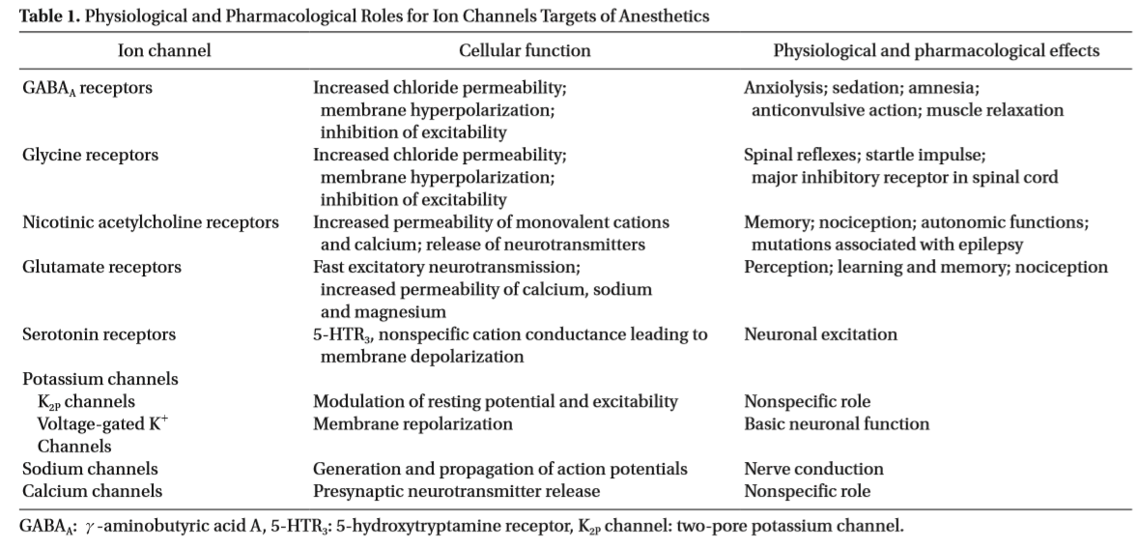

故我發現最初的兩個推論(1)是正確的，而關於(2)卻查不到相關的機制，應該是錯誤的，且機制(1)通常是Local anesthesia，而全身麻醉的機制大部分是作用在postsynaptic receptor並藉以改變膜電位。

然而，統整了目前的資訊，我也發現目前查到的所有麻醉機制，全部都和「改變膜電位」有關，都是anesthesia作用在離子通道蛋白上並調整通透性，進而使膜電位發生改變(通常最後結果為使膜電位降低，進而消除或減少action potential)

故在此我想到了一個問題：

有沒有辦法用一種「不改變膜電位的」方式來抑制訊息傳遞？例如，麻醉劑減少神經傳遞物的原料合成，就算action potential照常發生，也因為少了原料去做neurotransmitters，因而無法傳遞神經訊號？

在看了好幾篇資料後，我沒有找到可以「減少合成neurotransmitter原料」的anesthesia，但是卻找到了另一個阻斷神經傳導的機制，且此機制似乎真的是和膜電位改變無關的：

在實驗中發現propofol(一種general anesthesia)會抑制neurotransmitter的釋放(在neurosecretory PC12 cells, rat cortical neurons, Drosophila larval motor neurons皆觀察的到此現象)，說明了propofol 的作用應是presynaptic effect。

In our first line of experiments, we confirmed that a clinically relevant concentration of propofol (3 μM; Sall et al., 2012) indeed impairs neurotransmitter release in three different live neural preparations: neurosecretory PC12 cells(Figure 1B), cultured rat cortical neurons(Figure 1D), and Drosophila larval motor neurons (Figure 1F).

Together, these experiments across diverse systems indicate that a clinically relevant concentration of propofol potently disrupts neurotransmitter release and that this is a presynaptic effect. Importantly, the postsynaptic inhibitory ion channels that form the canonical target mechanism of propofol (Bali and Akabas, 2004, Franks, 2008) are unlikely to be involved in these presynaptic preparations. Other target mechanisms must therefore be present to significantly impair neurotransmission. [3]

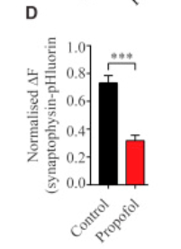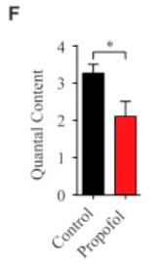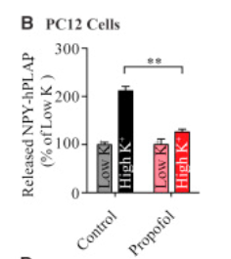

Figure 1B :neurosecretory PC12 cells Figure 1D:cortical neurons Figure 1F:Drosophila larval motor neurons

控制presynapse釋放neurotransmitters的蛋白質，例如syntaxin1A和SNAP-25，會在細胞膜上形成nanoclusters，並recruit vesicle-associated membrane protein 2 (VAMP2)到細胞膜上，最後才在synaptic release sites產生exocytosis以釋放neurotransmitters，於是我們假設propofol會影響這些結合在細胞膜上的蛋白，例如syntaxin1A

Key presynaptic release machinery proteins, such as syntaxin1A and SNAP-25, are organized in nanoclusters on the plasma membrane and can dynamically recruit vesicle-associated membrane protein 2 (VAMP2), leading to exocytosis at synaptic release sites (Sudhof, 2004, Südhof and Rizo, 2011). We hypothesized that, by segregating within the plasma membrane, propofol might compromise the function of membrane-bound SNARE proteins such as syntaxin1A.

為了觀察細胞膜上的syntaxin1A，實驗將mEos2 tagged在syntaxin1A以觀察，在PC12 cells中，發現syntaxin1A移動的情形比對照組少了很多(Figure 2D)，syntaxin1A 的coefficient distribution (immobile fraction增加)也說明了propofol的immobilization作用(Figure 2E)。同樣情形在PC12 cells未受刺激(無action potential)的情況下也觀察的到。

In order to assess the behavior of individual syntaxin1A proteins on the cell membrane, we tagged syntaxin1A with photoconvertible mEos2 and expressed this construct in PC12 cells.

The presence of 3 μM propofol within a preparation of stimulated PC12 cells significantly decreased the displacement of membrane-bound syntaxin1A compared to DMSO controls (Figure 2D; summed area under the MSD curve [AUC] statistics shown to the right). DMSO alone had no effect on syntaxin1A mobility. The immobilization effect of propofol was confirmed by plotting the diffusion coefficient distribution of syntaxin1A molecules, revealing an increased immobile fraction and a simultaneous decrease in the mobile fraction (Figure 2E; change in the mobile/immobile ratio shown to the right). We saw the same confining effects in unstimulated PC12 cells

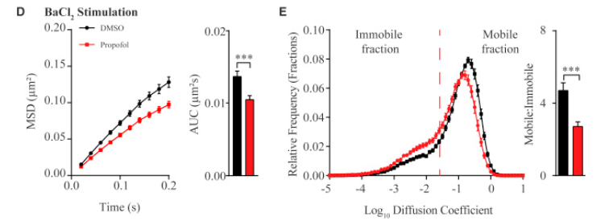

▲Figure 2

接著實驗也測試了同樣immobilization的狀況會不會在另一個SNARE protein, VAMP2上發生，VAMP2會和syntaxin1A與SNAP-25結合並形成三聚體，然而VAMP2平時皆位於synaptic vesicles上，無法被偵測(儀器只能偵測到細胞膜)，只有在vesicle fusion events時才會隨著vesicles translocate到細胞膜表面並形成三聚體，才會被偵測到。

We next investigated whether the mobility of a different SNARE protein, VAMP2, was also reduced by propofol. Vesicle-bound VAMP2, or synaptobrevin, interacts with membrane-bound syntaxin1A and SNAP-25 to form a fusion-ready ternary complex. Most of VAMP2 resides on synaptic vesicles inside the cell and is thus technically not accessible to our imaging of events on the plasma membrane. However, VAMP2 translocates to the plasma membrane following vesicle fusion events, where it remains bound to syntaxin1A and SNAP-25 prior to recycling

然而，在tag mEos2到VAMP2上後觀察卻顯示propofol反而增加了VAMP2的mobility，由於在細胞膜上偵測到的VAMP2是以three SNARE partners聚合的形式出現，故推測propofol對於syntaxin1A的作用應該是在這個三聚合體形成之前(我認為會這樣推測是因為若syntaxin1A和VAMP2結合後，syntaxin1A仍會被propofol作用而immobilized，那偵測VAMP2時應該會因此顯示mobility下降，但事實上卻沒有，說明在三聚合體形成後，propofol對syntaxin1A不會產生immobilization的效果)

By tagging VAMP2 with mEos2 (Figure S4A) we were thus able determine whether VAMP2 mobility on the plasma membrane mirrored syntaxin1A in the presence of propofol, as this would indicate a post-SNARE time frame for the effect of propofol. Using our PC12 cell preparation (Figure S4B), we found that propofol had no effect on VAMP2-mEos2 mobility (Figure S4C–S4F), showing instead a tendency for increased mobility.

Given that the three SNARE partners exist as a complex on the membrane only during or following vesicle fusion (Hayashi et al., 1994, Südhof and Rizo, 2011, Südhof and Rothman, 2009), our findings suggest that the effect of propofol on syntaxin1A mobility occurs prior to formation of the tetrameric complex.

既然上述實驗顯示propofol對syntaxin1A的作用是在三聚體形成之前，但在三聚體形成前，syntaxin1A會先和SNAP-25結合，那propofol對syntaxin1A的作用是在這兩者(syntaxin1A和SNAP-25)結合前還是結合後作用？也就是說，propofol對syntaxin1A的作用需不需要SNAP-25先和syntaxin1A結合？若是需要的，那代表只要把syntaxin1A和SNAP-25的interaction移除，就能阻止propofol對syntaxin1A作用。

SNAP-25 has been shown to form dimers with syntaxin1A on the plasma membrane (Rickman et al., 2004), where both interact with VAMP2 and a number of accessory proteins such as Munc13 and Munc18 to form SNARE complexes

If an interaction between SNAP-25 and syntaxin1A is required for propofol-mediated trapping of syntaxin1A in nanoclusters, then removing this interaction should eliminate the effect of propofol on syntaxin1A mobility. SNAP-25 interacts specifically with the SNARE motif of syntaxin1A (gold segment in Figure 6A, top) prior to forming a quadruple helix when both t-SNAREs meet with vesicle-bound VAMP2 (Weninger et al., 2008, Xiao et al., 2001). We reasoned that removing the SNARE motif from syntaxin1A might remove the propofol target and effectively abolish the effect of propofol on syntaxin1A mobility.

為了測試上述假設，實驗將syntaxin1A會和SNAP-25反應的motif切除，防止SNAP-25和syntaxin1A結合，切除部分的syntaxin1A結構會讓syntaxin1A的mobility稍微上升(我認為可能和分子量變小有關)，然而，在propofol作用之後，syntaxin1A的mobility不會下降，反而讓mobility變的更大，

To test this, we generated mEos2-tagged syntaxin1A deletion constructs in which the SNAP-25-interacting SNARE motif was entirely or partially removed (Figure 6A, middle and bottom). Removing all (Sx1AΔ183–265) or part (Sx1AΔ204–250) of the SNARE motif from syntaxin1A abolished the interaction with SNAP-25 (Figure 6B) as expected (Wu et al., 1999). Preventing this interaction with SNAP-25 or potentially also syntaxin1A homophilic interactions (Merklinger et al., 2017, Sieber et al., 2007) led to an increase in the mobility of Sx1AΔ204–250-mEos2 compared to wild-type (Figure 6C, gray versus black; Figures S5A and S5B). Most importantly, the addition of propofol not only failed to restrict the mobility of Sx1AΔ204–250-mEos2 but also increased mobility of the mutant protein even further

看似需要SNAP-25的假設是對的，然而，在這其中卻沒有考慮到一個可能的漏洞，有沒有可能決定propofol是否有作用的關鍵不是syntaxin1A和SNAP-25作用，而是syntaxin1A和其他蛋白作用，而syntaxin1A和此蛋白與和SNAP-25反應的syntaxin1A motif是相同或重複的？這樣推論便不能證明propofol的作用為SNAP-25 dependent。

故新增一個實驗，將syntaxin1A-mEos2和botulinum neurotoxin E light chain一起表現，E-LC會cleaves SNAP-25，進而防止SNAP-25-syntaxin1A heterodimers的形成，如此便可以很specific的找出是否為SNAP-25 dependent，而結果出來發現E-LC會讓propofol’s immobilizing effect失去作用(syntaxin1A mobility增加)，證明propofol對syntaxin1A的作用的確為SNAP-25 dependent。

However, in the preceding experiments, we could not exclude the possibility that proteins other than SNAP-25 might be required for the propofol effect on syntaxin1A clustering, also because the SNARE motif of syntaxin1A has been shown to drive homophilic interactions of the protein (Sieber et al., 2007). To confirm that the effect of propofol on syntaxin1A mobility is indeed SNAP-25 dependent, we co-expressed syntaxin1A-mEos2 with botulinum neurotoxin E light chain (BoNT/E-LC), which cleaves SNAP-25 and therefore prevents formation of SNAP-25-syntaxin1A heterodimers on the plasma membrane

BoNT/E-LC expression does not significantly alter syntaxin1A mobility (Figures S6A and S6B) as has also been shown previously (Kasula et al., 2016, Ribrault et al., 2011). However, it completely abolished propofol’s immobilizing effect and instead led to increased syntaxin1A mobility

最後要證明的點是：如何確定propofol造成的syntaxin1A immobilization導致了propofol impairs exocytosis？但是在這一篇沒有給出很明確的分子機制，而是一個證明的方法：

之前研究發現表現truncated isoform of syntaxin1A (Sx1A227)會阻止propofol對exocytosis造成的損害，若假設propofol impairs exocytosis是因為syntaxin1A immobilization的緣故，那Sx1A227表現應該有很大的可能可以阻止propofol造成的syntaxin1A immobilization

實驗證明Sx1A227可以和SNAP-25和wild-type syntaxin1A反應，但不會和VAMP2反應，說明Sx1A227是會作用且影響到SNARE formation的，進一步實驗中，在生物體內把wild-type syntaxin1A-mEos2與Sx1A227一起表現，加入propofol，發現確實阻止了propofol對syntaxin1A mobility的影響，間接證明很有可能propofol作用在postsynapse的這些effects(mobilization和exocytosis)是彼此牽連的

We have shown that propofol impairs exocytosis (Figure 1) and propose that this is a consequence of syntaxin1A immobilization or clustering (Figures 2, 3, 4, 5, and 6). Although we have not yet established such causality, our model predicts that genetic manipulations affecting one presynaptic readout (syntaxin1A mobility) should also affect the other readout (exocytosis).

Previous work has found that co-expression of a truncated isoform of syntaxin1A (Sx1A227; Figure 7A) rescues the effect of propofol on exocytosis in PC12 cells (Herring et al., 2011). We therefore tested whether this genetic manipulation also rescued the effect of propofol on syntaxin1A mobility. We first confirmed that the construct indeed rescued evoked exocytosis (Figure 7B). We added a hemagglutinin (HA) tag at the N terminus of the truncated construct (Figure 7A, red) to determine whether it interacted with functional SNARE proteins, including wild-type syntaxin1A (tagged with mEos2), SNAP-25 (tagged with Myc), and VAMP2 (tagged with GFP). Co-immunoprecipitation experiments (Experimental Procedures) showed it interacts with SNAP-25, but not VAMP2 (Figures 7C and 7D). Sx1A227 also interacts with wild-type syntaxin1A, alongside SNAP-25 (Figure 7E). This suggests a direct effect on functional syntaxin1A/SNAP-25 dimers rather than a parallel effect unrelated to SNARE formation.

We next co-transfected PC12 cells with wild-type syntaxin1A-mEos2 and Sx1A227 (Figures S7A–S7C) and tracked syntaxin1A-mEos2 mobility in the presence and absence of propofol. Adding Sx1A227 to the cells had no effect on syntaxin1A mobility in the absence of propofol (Figures S7D and S7E). However, adding the truncated construct abolished the effect of propofol on syntaxin1A mobility in both stimulated and unstimulated cells (Figures 7F, 7G, S7F, and S7G). This shows that the same manipulation in PC12 cells (co-expressing Sx1A227) rescues both exocytosis and syntaxin1A mobility, suggesting that these presynaptic effects of propofol are linked.

總結：

目前得知propofol 會作用在SNAP-25-syntaxin1A heterodimers上並造成immobilization，然而，在包含VAMP2的三聚體中卻觀察不到immobilization的發生，可以推測SNAP-25-syntaxin1A heterodimers被propofol作用後即無法再和VAMP2形成三聚體(否則形成的三聚體應該會有immobilization)，因而無法執行exocytosis，因此抑制了neurotransmitters的釋放，上述進行的Sx1A227實驗也支持這個推測。

此機制就是一個以「不改變膜電位」的方式，透過使「執行exocytosis的蛋白」immobilization的方式來阻斷exocytosis的發生，沒有exocytosis，neurotransmitters也就無法釋放，故神經訊息也無法繼續傳遞下去。

Question 2:

從dendrite接受到的訊號經過整合後如何傳遞給axon？

Answer 2:

1. Dendrite接收synapse的訊號時，何種NT(neurotransmitter)會決定傳遞何種訊號。Facilitatory NTs（比方說glutamate）會與其受體結合，glutamate receptor會活化sodium channel使dendrite發生influx of Na+造成depolarization，進而形成EPSP。Inhibitory NTs（比方說GABA）會與其受體結合，GABA receptor會活化chloride channel使dendrite發生influx of Cl-造成hyperpolarization，進而形成IPSP。[4]
2. 不論是EPSP還是IPSP，他們在dendrite都是graded potential，graded potential與action potential不一樣，他並不遵守all-or-none，他也沒有那麼高的電位而是1-50mV之間不等、浮動的低電位，而且graded potential只能傳遞較短的距離。不過，經證實graded potential可經由EEG(electroencephalogram)測得。[5]
3. 在graded potential 形成後，神經訊號的傳遞會因為神經的種類而有所不同。在non-perceptual neuron，來自各個dendrite的graded potential會傳遞到soma的membrane，並會將不論是EPSP還是IPSP進行整合運算，這個過程稱作summation，經過summation的神經訊號傳至axon hillock時，並非再以graded potential的傳遞方式，而是改以action potential的方式決定是否fire hillock’s potential，如果summation的結果超過threshold，神經訊號便會經由axon傳遞至下一個neuron，否則就會回到原本的membrane potential。[5]
4. 至於perceptual neuron，graded potential會經由molecular grids轉變成primary thought。原本寫在這後面的段落是我從The Biology of Thought經過閱讀整理後的解釋，但在和老師討論後，我自己也覺得這個解釋太唬爛了，所以就此停住。不過前面的論述，我在Netter’s Atlas of Neuroscience也有看到類似的解釋，應該屬實。

Reference

[1] doi: 10.2344/0003-3006-59.2.90

[2] doi: 10.4097/kjae.2010.59.1.3

[3] doi: 10.1016/j.celrep.2017.12.054

[4] doi: 10.1016/B978-0-12-800900-0.00002-6

[5] doi: 10.1016/B978-0-12-800900-0.00006-3

[6] doi: 10.1016/B978-0-12-800900-0.00007-5